What is a cover letter? | A cover letter is typically sent with your resume when applying for a job.  Cover letters:  - Introduce you to the potential employer/organization  - Explains why you are sending your resume  - Provides additionl information about you
- Consider these tips to write an effective cover letter. | - Use simple, straight forward language and grammar  - Use correct grammar and spelling  - Let your letter reflect your individuality  - Send your letter directly to an individual if possible  - Spell letter recipient’s name correctly  - Be friendly, not pushy  - Stick to the point of the letter  - Make sure to proofread
- Include the following in the body of the cover letter:  First paragraph – reason for writing  Second paragraph – point out qualifications  Third paragraph – call attention to resume, reiterate interest  (*CCRS Canvas Module has easy cover letter template for you to download) | 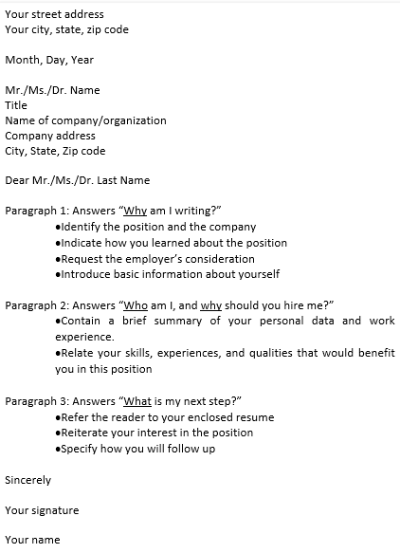
- Log into Naviance |   Username: district ID#  Password: district password
- Task Completion: | Dowload Cover Letter Template from CCRS Canvas module.  Complete/save cover letter.  Click the title of the task, Upload Completed Cover Letter. Click Browse… to locate your saved cover letter and upload it to the task.

